Location  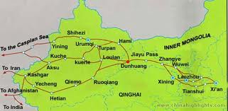 | The latitude and longitude of the Silk Road is 12.9172 and 77.622956.
Place  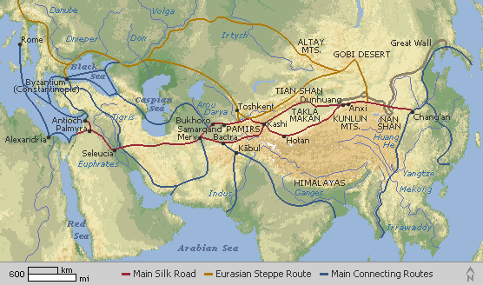 | The silk road has the Himalayas below it as well as the Gobi Desert above it. There are hundreds of small villages on the silk road. Toward the west is the Chaplin Sea.
Region  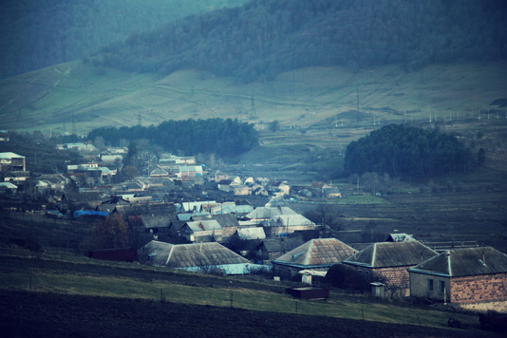 | The Kushan people (a village) were the first to show Buddha in human form. Some see the man Zhang Qian as the father of the Silk Road.
Movement  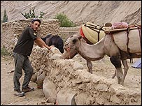 | The people have used camels as movement but the main form of transport is a horse. The horses are able to pull wagons full of food and are able to have one rider. The people traded silk cloths and domesticated animals. There was fruit and grain traded on the Silk Road.
Interaction  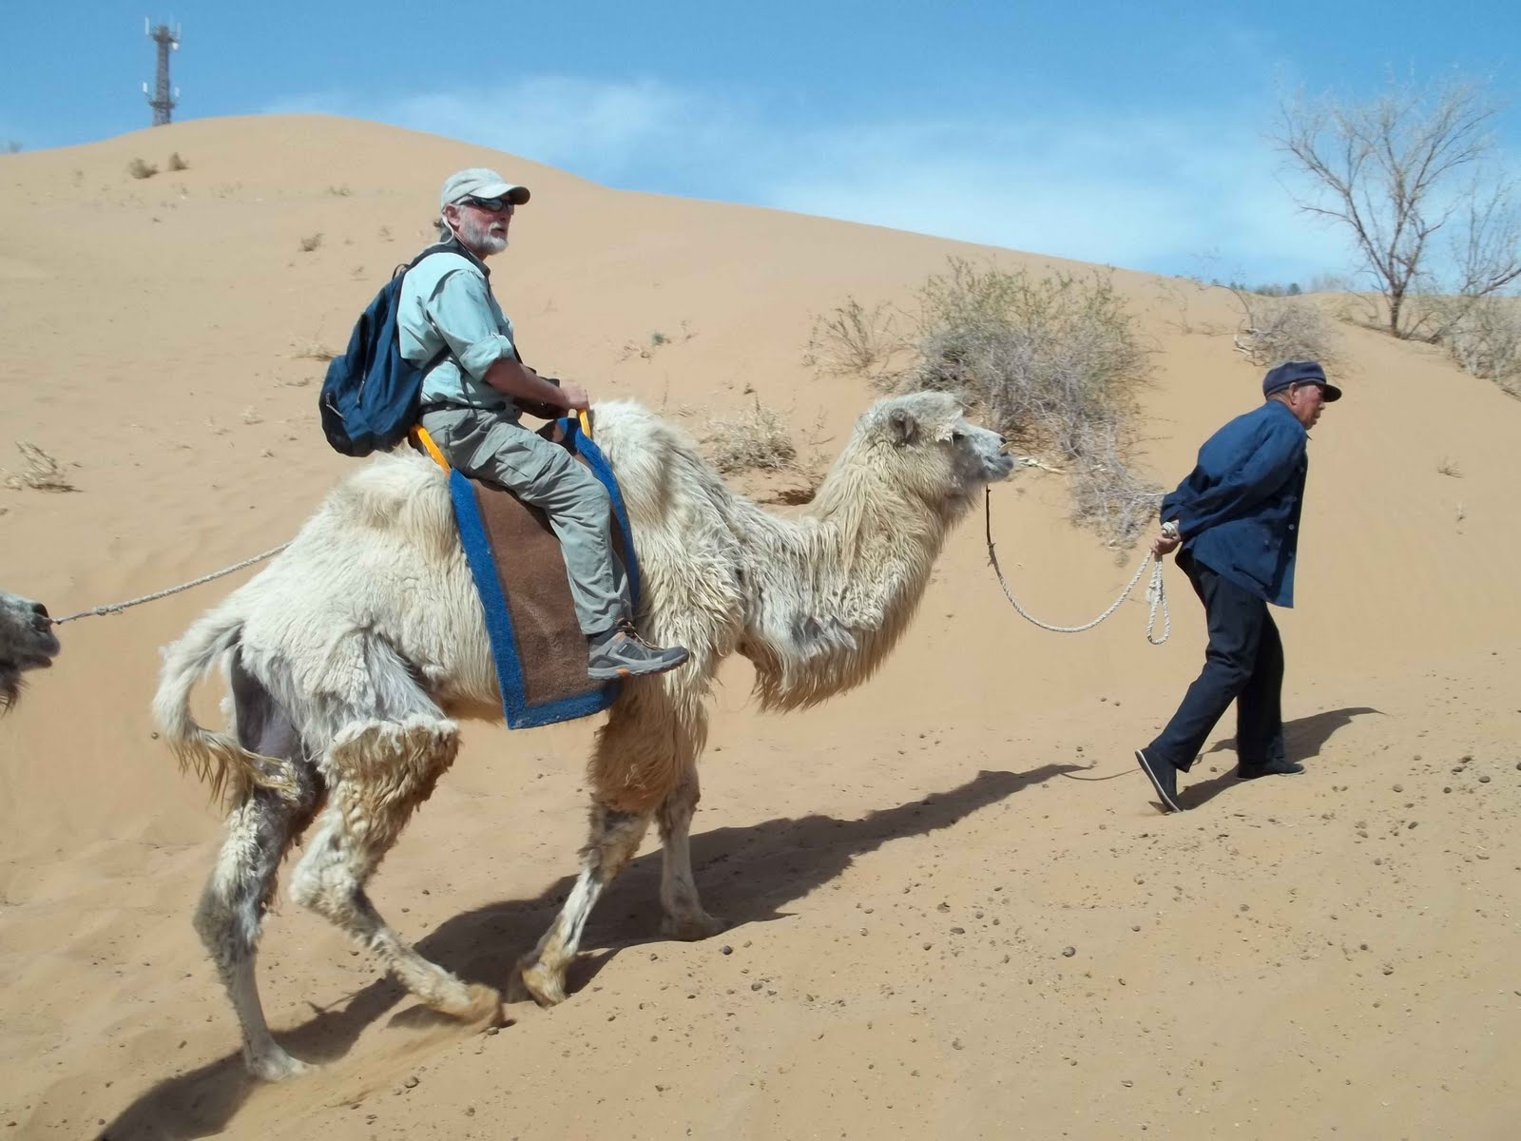 | The change of the environment caused the objects bartered on the Route to change. The people used the changed environment to make new objects that will increase their profit.

