Achievement and Image | Detailed Explanation
Pulleys  http://www.school-for-champions.com/machines/simple_machines.htm  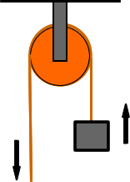 | The pulleys were used to move goods like valuable ores and grains or oats.
Wheelbarrows  http://www.lowtechmagazine.com/2011/12/the-chinese-wheelbarrow.html  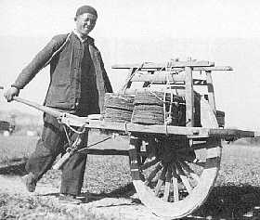 | Like the pulleys, wheelbarrows were used to move goods like valuable ores and grains or oats.
The Loom  http://www.schachtspindle.com/our_products/table.php  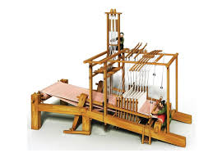 | The loom was used for weaving garments of silk for the rich and cloths for the poorer.
Cast Iron Tools  http://www.arscives.com/historysteel/cn.steelswords.htm  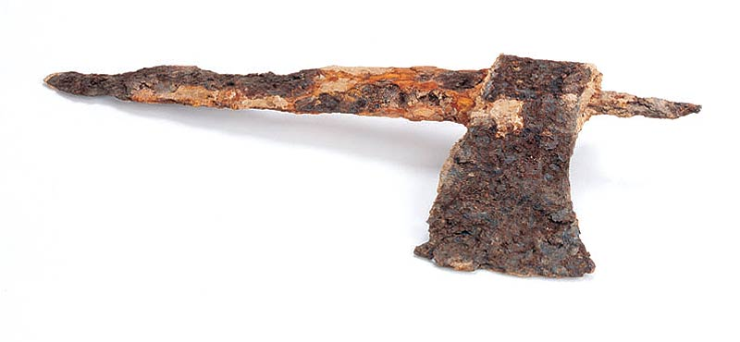 | The iron tools were used instead of stone because the iron lasted longer and was sharper than stone.
The Paper Making Process  http://chem-is-easy.blogspot.com/2013/03/how-to-make-paper-chemists-recipe.html  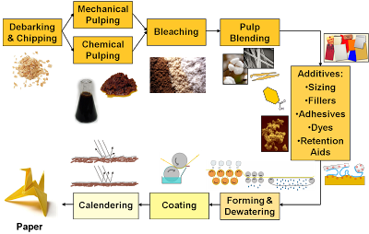 | The first paper was made of Cannabis sativa (hemp) (distinct variety of marijuana). Then a man named Cai Lun made a paper of bamboo fibers and the inner bark of a mulberry tree, wet them, pounded then with a wooden mallet and let them dry. When the water evaporated, the fibers were left and the first sheet of paper was made.
Bellows  http://www.design-your-outdoor-fireplace.com/Fireplace-Screen-3.shtml  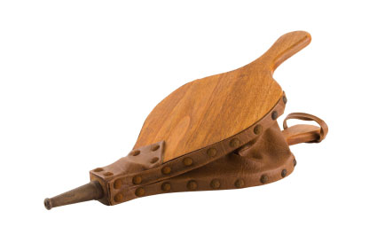 | Thanks to bellows, the air would be pumped into the furnaces. This caused the fire to burn hotter and stronger. Iron could now be smelted.
Water-powered trip-hammer  http://www.ancient.eu.com/Han_Dynasty/  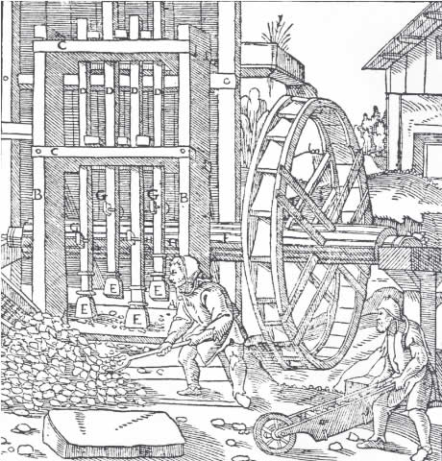 | The water-powered trip-hammers would crush the ores under them. This machine was also used to crush oats or grain.

