Characteristic | Important Facts, Evidence and Explanations
Government  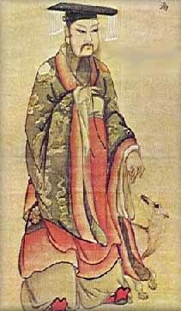 | I think that this picture relates to the characteristic of civilization because the picture shows a Chinese Emperor. The Emperors were like our president as he was the ruler of the country.
Religion  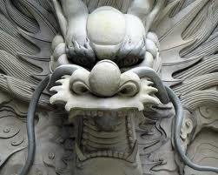 | The ancient Chinese believed in a powerful dragon that lived in all of the rivers, lakes and seas in and around China.
Social Structure  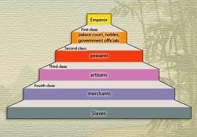 | This picture shows how the Emperor is the highest social class there was in ancient China. The palace court, nobles, and government officials make up the first class while peasants are second. Artisans are third class with the merchants fourth class. At the bottom of the pyramid are slaves.
Technology  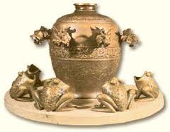 | This is an earthquake warning system. When a small earthquake wave hit the device, the little balls would fall from the dragon heads into the frogs’ mouths. This showed great advancement without the usage electronics we use today.
Stable Food Supply  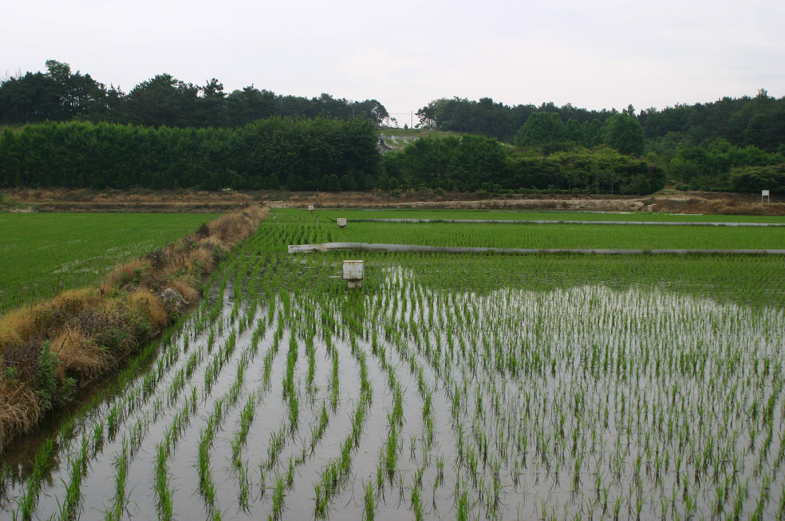 | This shows the stable food supply because the rice patties were used to farm rice. This was a part of the slave’s daily life. They worked all day in the fields, planting or harvesting the rice.
Art  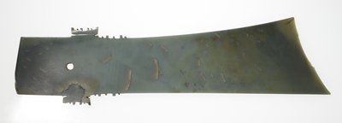 | This piece of art showed the Shang Dynasty valued military strength. It is a dagger
Writing  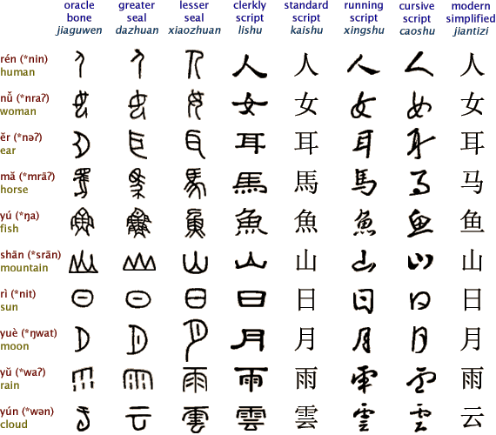 | The written language has stayed the same. The four main types of ancient Chinese writings are listed from oldest to modern times: Oracle Bone (Jiaguwen), Greater Seal (Dazhuan), Lesser Seal (Xiaozhuan), and modern day Clerkly Script (Lishu)

